## PROJECT REPORT ON

**HOME LOAN SERVICE**

## SUBMITTED IN PARTIAL FULFILMENT

## OF

## THE REQUIREMENTS OF

## THE AWARDS OF THE

#### PG-Diploma in Advanced Computing

**Offered By**

**C-DAC Hyderabad**

BY

|  |  |
| --- | --- |
| Name | PRN No |
| Abhiram Belorkar | 220941220031 |
| Shreyansh Ranka | 220941220170 |



**Advanced Computing Training School  
C-DAC  
Pune**

**September 2022**



Certificate

This is to certify that this is a bonafide record of project entitled **HOME LOAN SERVICE**

|  |  |
| --- | --- |
| Name | PRN No |
| Abhiram Belorkar | 220941220031 |
| Shreyansh Ranka | 220941220170 |

They have completed project work as part of **Diploma in Advanced Computing (September 2022-Batch)**, a PG course offered by C-DAC Pune.

They have completed project work under my supervision and their performance found to be good.

Signature of Project guide

(Mrs. Sonali Mogal)

**ACKNOWLEDGEMENT**

**Home Loan Service** project has presented, an objective, a goal, a challenge. This project marks the final hurdle that we tackle, of hopefully what would be one of the many challenges we have taken upon and yet to take.

However, we could not have made it without the support and guidance from the following. Firstly, we want to take this opportunity to have special thanks to our guide **Mrs. Sonali Mogal** who helped us throughout this project by providing valuable guidance and advice as well as acquiring all components needed for this project to become a success.

(PG-DAC September 2022)

|  |  |  |  |
| --- | --- | --- | --- |
|  |  | Name | PRN No |
|  |  | Abhiram Belorkar | 220941220031 |
|  |  | Shreyansh Ranka | 220941220170 |
|  |  |  |  |
|  |  |  |  |

**TABLE OF CONTENTS**

|  |  |
| --- | --- |
| **TOPIC** | **PAGE** |
| **Abstract** | **I** |
| **Introduction** | **1** |
| 1. **Project Requirements** | **2** |
| * 1. **Problem Statement** | **2** |
| * 1. **Software & hardware Requirements** | **2** |
| * 1. **Languages** | **2** |
| 1. **Implementation** | **3** |
| * 1. **Frontend** | **3** |
| * 1. **Backend** | **3** |
| * 1. **Database** | **4** |
| * + 1. **Tables (Blood Bank, City, District, State, Donor, Stock, User)** | **4** |
| 1. **Objectives** | **7** |
| 1. **Functional Specification** | **7** |
| 1. **System Diagrams** | **9** |
| * 1. **System E-R Diagram** | **9** |
| * 1. **Donor Use Case Diagram** | **10** |
| * 1. **Blood Bank Use Case Diagram** | **10** |
| * 1. **System Flow Diagram** | **11** |
| * 1. **Class Diagram** | **12** |
| 1. **Frontend and Backend Connection** | **13** |
| 1. **Project Screenshots** | **14** |
| 1. **Advantages** | **21** |
| 1. **Disadvantages** | **21** |
| 1. **Application** | **21** |
| 1. **Future Scope** | **21** |
| 1. **Conclusion** | **22** |

**Home loan service**

**Abstract:**

The project entitled “Home Loan Service” is to be developed for maintaining the bank activities like, customer preferences, customer enquiry, interest rates, customer EMI, personal loan, mortgage loan, Home Loan, Customer follow ups details, customer feedback from entry and employee details.

The system is efficient in generating reports which will help in the maintaining records of the customer. Microfinance is a project which has become a mainstream instrument for providing access to formal financial services for common people. This project is developed to maintain all the details of the users and to develop online portal.

**INTRODUCTION**

A home loan is a secured loan that is obtained to purchase a property by offering it as collateral. Home loans offer high-value funding at economical interest rates and for long tenors. They are repaid through EMIs. After repayment, the property's title is transferred back to the borrower.

The project objective is to create a web-based application for banks and financial institutions to manage home loan applications from their administrative backend. The backend will be responsible for managing the loan application process, which includes validating user inputs, processing applications, and storing data in a database.

The frontend will be user-friendly, with a dashboard that provides an overview of all applications, filters to search for specific loan applications, and features for managing applications such as approving or rejecting them, updating their statuses, and sending notifications to applicants. This software is primarily aimed at individuals who are interested in obtaining a home loan from a bank. Its purpose is to simplify the loan application process and make it easier for banks to manage and process applications.

1. **PROJECT REQUIREMENTS**

**1.1 Problem Statement:**

* With the growing economy, population and needs of people the demand of houses has also increased.
* Due to the lack of funds or liquidity or slow processing of home loan people are struggling to buy house.
* The bank is not having robust and fast system and mainly to easy access of customer enquiry or loan application data to fast track loan processing.

**1.2 Software & hardware Requirements:**

**Hardware Specification:**

1. Hard Disk - 250 GB
2. Min Memory - 4GB RAM
3. Processor - Dual Core

**Software Specification:**

1. Operating System - Windows 8
2. Database – MySQL

**1.3 Languages:**

1. Java
2. React JS
3. JavaScript
4. HTML
5. SQL
6. CSS
7. Bootstrap
8. **Implementation**

We are going to describe actual implementation of Home Loan Service. We implement that system by implementing a website. Hence, we need to create Web Pages for their separate application. Basically, to install System we need dual core processor as base platform. To store programs and images we also required a secondary memory supposed to be max up to 250GB. To process current action, we required main memory of 4 GB enough.

Now after that we should have some software requirements and that to be Operating System e.g., Windows 8 to control process carried out by our system. Next is Database i.e., MySQL for Database storage and data handling. After that we need editor Visual Studio Code and Spring Tool Suite for actual implementation of code, and postman to test our code.

This project purely follows the view of distributed architecture having centralized storage of the database part. Let we divide our project in three part and that are frontend, backend and database respectively. Let we overlook each one after one. Since we divide project onto some separate part and developed it with individual assumptions. Analyses each part with try and error method. After perfect testing we deploy the test code. Integrate all that parts and again testing the implementation. In this way we successfully develop the project i.e., Home Loan Service.

**2.1. Frontend:**

The front end of a website is the part that users interact with. Everything that you see when you’re navigating around the Internet, from fonts and colors to dropdown menus and sliders, is a combo of HTML, CSS, JavaScript and ReactJS being controlled by your computer’s browser. It implements the structure, design, behavior, and animation of everything you see on the screen when you open up websites, web applications, or mobile apps.

The core 3 **technologies** that all modern **front**-**end** web developers work to master are HTML5, CSS, JavaScript and React JS. It simplifies web development by offering automatic view/model synchronization.

**2.2. Backend:**

A back-end web developer is responsible for server-side web application logic and integration of the work front-end developers do.

**2.3. Database:**

A database is a collection of information that is organized so that it can be easily accessed, managed and updated. Data is organized into rows, columns and tables, and it is indexed to make it easier to find relevant information.

**2.3.1 Table**

There are twenty-four tables created in the project which are attached below:

|  |  |  |  |  |  |  |  |
| --- | --- | --- | --- | --- | --- | --- | --- |
| **1)** | | **Customer** | | | | |  |
|  | |  | |  | | |  |
|  | | **Sr No** | | **Fields** | | | **Data Type** |
|  | | 1 | | customerId | | | Int |
|  | | 2 | | customerName | | | String |
|  | | 3 | | customerDateOfBirth | | | String |
|  | | 4 | | customerAge | | | Int |
|  | | 5 | | customerGender | | | String |
|  | | 6 | | customerEmail | | | String |
|  | | 7 | | customerMobileNumber | | | Double |
|  | | 8 | | customerAdditionalMobileNumber | | | Double |
|  | | 9 | | customerAmountPaidForHome | | | Double |
|  | | 10 | | customerTotalLoanRequired | | | Double |
|  | | 11 | | customeraddresscustomeraddressid | | | Int |
|  | | 12 | | educationalinfoeducationid | | | Int |
|  | | 13 | | enquirydetailsid | | | Int |
|  | | 14 | | familydependentintodependentinfoid | | | Int |
|  | | 15 | | professionprofessionid | | | Int |
|  | | 16 | | currentdetailscurrentloanid | | | Int |
|  | | 17 | | previousloanpreviousloanid | | | Int |
|  | | 18 | | accountdetailsaccountid | | | Int |
|  | | 19 | | allpersonaldocdocumentid | | | Int |
|  | | 20 | | customerverificationverificationid | | | Int |
|  | | 21 | | guarantordetailsguarantorid | | | Int |
|  | | 22 | | ledgerledgerid | | | Int |
|  | | 23 | | loandisbursementagreementid | | | Int |
|  | | 24 | | mortgagedetailsdetailsmortgageid | | | Int |
|  | | 25 | | propertyinfopropertyid | | | Int |
|  | | 26 | | Sanctionlettersanctionid | | | Int |
| **2)** | **EnquiryDetails** | | | |
|  |  | |  | |
|  | **Fields** | | **Data Type** | | |
|  | cID | | Int | | |
|  | firstName | | String | | |
|  | lastName | | String | | |
|  | age | | Int | | |
|  | email | | String | | |
|  | mobileNo | | Double | | |
|  | pancardNo | | Double | | |

|  |  |  |
| --- | --- | --- |
| **3)** | **Cibil** |  |
|  |  |  |
|  | **Fields** | **Data Type** |
|  | cibilId | Int |
|  | cibilScore | Int |
|  | cibilScoreDateTime | String |
|  | status | String |
|  | remark | String |

|  |  |  |
| --- | --- | --- |
| **4)** | **EducationalInfo** |  |
|  | **Fields** | **Data Type** |
|  | educationId | Int |
|  | educationType | string |

|  |  |  |
| --- | --- | --- |
| **5)** | **AllPersonalDocs** |  |
|  |  |  |
|  | **Fields** | **Data Type** |
|  | documentID | Int |
|  | addressProof | byte[] |
|  | panCard | byte[] |
|  | IncomeTax | byte[] |
|  | addharCard | byte[] |
|  | photo | byte[] |
|  | signature | byte[] |
|  | thumb | byte[] |
|  | bankCheque | byte[] |
|  | salarySlips | byte[] |

|  |  |  |
| --- | --- | --- |
| **7)** | **CustomerAddress** |  |
|  |  |  |
|  | **Fields** | **Data Type** |
|  | customerAddressId | Int |
|  | permanentAddress | PermanentAddress |
|  | localAddress | LocalAddress |

|  |  |  |
| --- | --- | --- |
| **8)** | **PermanentAddress** |  |
|  |  |  |
|  | **Fields** | **Data Type** |
|  | permanentAddressId | Int |
|  | areaname | String |
|  | cityname | String |
|  | district | String |
|  | state | String |
|  | pincode | Long |
|  | houseNumber | Int |
|  | streetName | String |
|  |  |  |
|  |  |  |
|  |  |  |
| **9)** | **LocalAddress** |  |
|  |  |  |
|  | **Fields** | **Data Type** |
|  | localAddressId | Int |
|  | areaname | String |
|  | cityname | String |
|  | district | String |
|  | state | String |
|  | pincode | Long |
|  | houseNumber | Int |
|  | streetName | String |

|  |  |  |
| --- | --- | --- |
| **10)** | **MortgageDetails** |  |
|  |  |  |
|  | **Fields** | **Data Type** |
|  | mortgageId | Int |
|  | mortgagePropertyValue | Double |
|  | mortgagePropertyProof | byte[] |
|  | mortgagePropertyType | string |
|  | mortgageLoanOnProperty | Double |
|  | mortgagePropertyInsurance | byte[] |

|  |  |  |
| --- | --- | --- |
| **11)** | **Profession** |  |
|  |  |  |
|  | **Fields** | **Data Type** |
|  | professionid | Int |
|  | professiontype | String |
|  | professionsalary | Double |
|  | professionsalaryType(cash/account) | String |
|  | professionworkingperiod | String |
|  | professionDesignation | String |
|  | professionsalaryslips | byte[] |

|  |  |  |
| --- | --- | --- |
| **12)** | **CurrentLoanDetails** |  |
|  |  |  |
|  | **Fields** | **Data Type** |
|  | currentloanId | Int |
|  | currentloanNo | Int |
|  | Emidetails | EMIDetails |
|  | loanAmount | Double |
|  | rateOfInterest | Int |
|  | tenure | Int |
|  | totalAmounttobepaidDouble | Double |
|  | processingFees | Int |
|  | totalInterest | Double |
|  | sanctionDate | String |
|  | remark | String |
|  | status | String |

|  |  |  |
| --- | --- | --- |
| **13)** | **EMIDetails** |  |
|  |  |  |
|  | **Fields** | **Data Type** |
|  | emailID | Int |
|  | emiAmountMonthly | Double |
|  | nextEmiDueDate | String |
|  | previousEmiStatus | String |

|  |  |  |
| --- | --- | --- |
| **14)** | **PreviousLoan** |  |
|  |  |  |
|  | Fields | Data Type |
|  | previousLoanId | Int |
|  | previousLoanAmount | Double |
|  | previousLoanTenure | Int |
|  | previousLoanpaidAmount | Double |
|  | previousLoanremainingAmount | Double |
|  | previousLoandeafulterCount | Int |
|  | previousLoanbankDetails | PreviousLoanBank |
|  | previousLoanStatus | String |
|  | previousLoanRemark | String |

|  |  |  |
| --- | --- | --- |
| **15)** | **PreviousLoanBank** |  |
|  |  |  |
|  | **Fields** | **Data Type** |
|  | branchId | Int |
|  | branchName | String |
|  | branchCode | Double |
|  | branchType(main/sub) | String |
|  | IFSC code | String |
|  | MICR code | String |
|  | ConatctNumber | Double |
|  | BankAddress | BankAddress |
|  | Email | String |
|  | status | String |

|  |  |  |
| --- | --- | --- |
| **16)** | **AccountDetails** |  |
|  |  |  |
|  | **Fields** | **Data Type** |
|  | accountId | Int |
|  | accounType | String |
|  | accountBalance | Double |
|  | accountHolderName | String |
|  | accountStatus | String |
|  | accountNumber | Long |

|  |  |  |
| --- | --- | --- |
| **17)** | **PropertyInfo** |  |
|  |  |  |
|  | Fields | Data Type |
|  | propertyId | Int |
|  | propertyType | String |
|  | propertyArea | String |
|  | constructionArea | String |
|  | propertyPrice | Double |
|  | constructionPrice | Double |
|  | propertyDocuments | Byte[] |
|  | priceProofs | Byte[] |
|  | propertyAddress | PropertyAddress |

|  |  |  |
| --- | --- | --- |
| **18)** | **PropertyAddress** |  |
|  |  |  |
|  | **Fields** | **Data Type** |
|  | PropertyAddressId | Int |
|  | areaname | String |
|  | cityname | String |
|  | district | String |
|  | state | String |
|  | pincode | Long |
|  | streetName | String |

|  |  |  |
| --- | --- | --- |
| **19)** | **GuarantorDetails** |  |
|  |  |  |
|  | **Fields** | **Data Type** |
|  | GuarantorId | Int |
|  | GuarantorName | String |
|  | GuarantorDateOfBirth | String |
|  | GuarantorRelationshipwithCustomer | String |
|  | GuarantorMobileNumber | Long |
|  | GuarantorAdharCardNo | Long |
|  | GuarantorMortgageDetails | String |
|  | GuarantorJobDetails | String |
|  | GuarantorLoaclAddress | String |
|  | GuarantorPermanentAddress | String |

|  |  |  |
| --- | --- | --- |
| **20)** | **LoanDisbursement** |  |
|  |  |  |
|  | **Fields** | **Data Type** |
|  | agreementId | Int |
|  | loanNo | Int |
|  | agreementDate | String |
|  | amountPayType | String |
|  | totalAmount | Double |
|  | bankName | String |
|  | accountNumber | Long |
|  | IFSCCode | String |
|  | accountType | String |
|  | transferAmount | Double |
|  | paymentStatus | String |
|  | amountPaidDate | String |

|  |  |  |
| --- | --- | --- |
| **20)** | **Ledger** |  |
|  |  |  |
|  | **Fields** | **Data Type** |
|  | ledgerId | Int |
|  | ledgerCreatedDate | String |
|  | totalLoanAmount | Double |
|  | payableAmountwithInterest | Double |
|  | tenure | Int |
|  | monthlyEMI | Double |
|  | amountPaidtillDate | Double |
|  | remainingAmount | Double |
|  | nextEmiDatestart | String |
|  | nextEmiDateEnd | String |
|  | defaulterCount | Int |
|  | previousEmitStatus | String |
|  | currentMonthEmiStatus | String |
|  | loanEndDate | String |
|  | loanStatus | String |
|  |  |  |
| **21)** | **SanctionLetter** |  |
|  |  |  |
|  | **Fields** | **Data Type** |
|  | sanctionId | Int |
|  | sanctionDate | String |
|  | applicantName | String |
|  | contactDetails | Double |
|  | producthomeEquity | String |
|  | loanAmtSanctioned | Double |
|  | interestType | String |
|  | rateOfInterest | Int |
|  | loanTenure | Int |
|  | monthlyEmiAmount | Double |
|  | modeOfPayment | String |
|  | remarks | String |
|  | termsCondition | String |
|  | status | String |

|  |  |  |
| --- | --- | --- |
| **22)** | **CustomerVerification** |  |
|  |  |  |
|  | **Fields** | **Data Type** |
|  | verificationID | Int |
|  | verificationDate | String |
|  | status | String |
|  | remarks | String |

4. Objectives

1. 4. Objectives
2. 4. Objectives
3. 4. Objectives
4. 4. Objectives
5. 4. Objectives
6. 4. Objectives
7. Objectives
8. The
9. 4. Objectives
10. The goal of the project is to develop a web application for blood banks to manage
11. information about their donors and blood stock. The main objectives of this
12. website development can be defined as follows:
13. 1. To develop a system that provides functions to support donors t
14. **Objectives**

* The main objective of this project is to buy a Home through finance Loan Company and to implement all the loan process by developing a code.
* First here, if we want to buy a Home then we will go to Builder, and he will explain the whole process to us and gives a quotation.
* If we do not have that much money in current situation, then he will suggest us to take a loan.
* As already some banks have tied up with them e.g., ICICI, HDFC, SBI, and some other finance companies.
* Then they will suggest us those providers and there is one relation executive person will contact you and explain all the process of Loan.
* Every bank has different process.

1. **Functional Specification**

**Admin**

* Admin can login and manage loan enquiry and application status

**Bank**

* Register and Login
* Manage home loan enquiry.
* Update application status.

**User**

* Admin can search for enquiry of home loan.
* Admin can search for application status of customer state, district and city wise.

1. **System Diagrams:**
   1. **System E-R Diagram:**

~~Database is absolutely an integral part of software system. To fully utilize ER Diagram in database engineering guarantee you to produce high quality database design to use in database creation, management and maintenance. An ER model also provides a means for communication.

* 1. **Diagram, engineering drawing

     Description automatically generatedUse Case Diagram :**
  2. **System Flow Diagram**

* 1. **A picture containing diagram

     Description automatically generatedClass Diagram**

1. **Frontend and Backend Connection**

**~~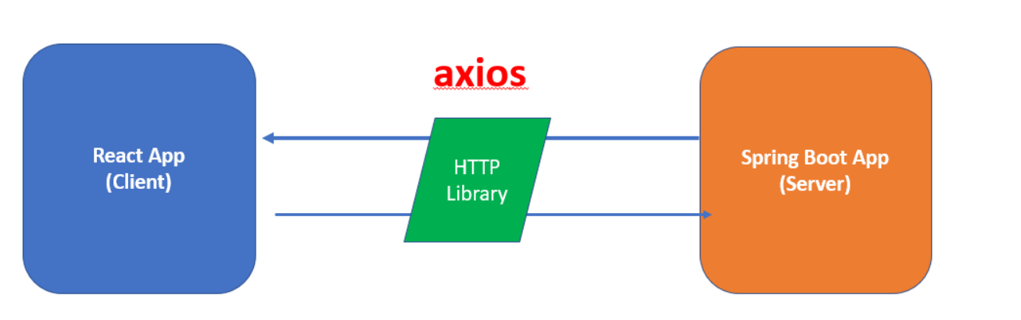~~**

**Axios:**

Axios, which is a popular library is mainly used to send asynchronous HTTP requests to REST endpoints. This library is very useful to perform CRUD operations.

* This popular library is used to communicate with the backend. Axios supports the Promise API, native to JS ES6.
* Using Axios we make API requests in our application. Once the request is made we get the data in Return, and then we use this data in our project.

1. **PROJECT SCREENSHOTS**

Home Page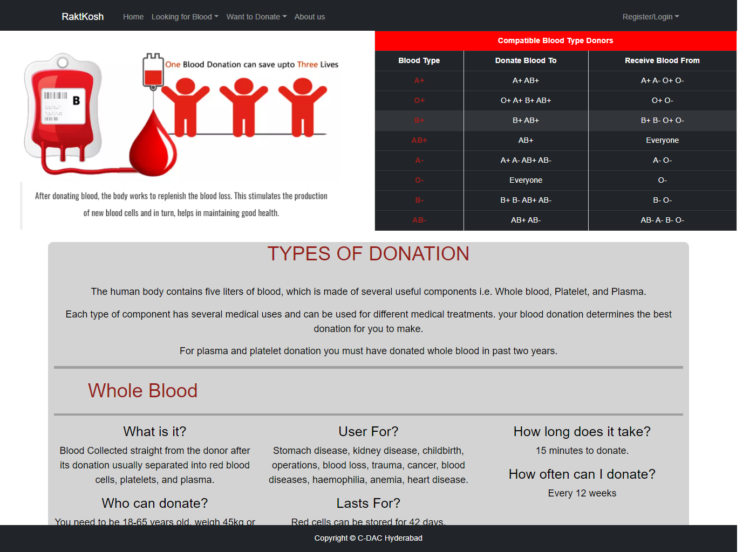

Donor Registration Page

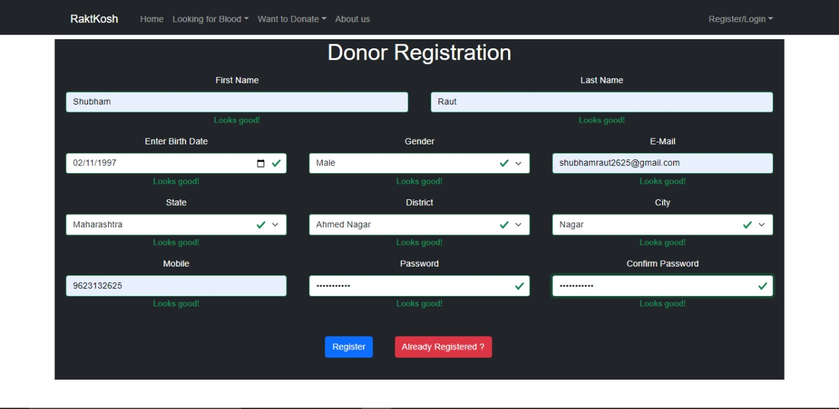

Donor Login Page

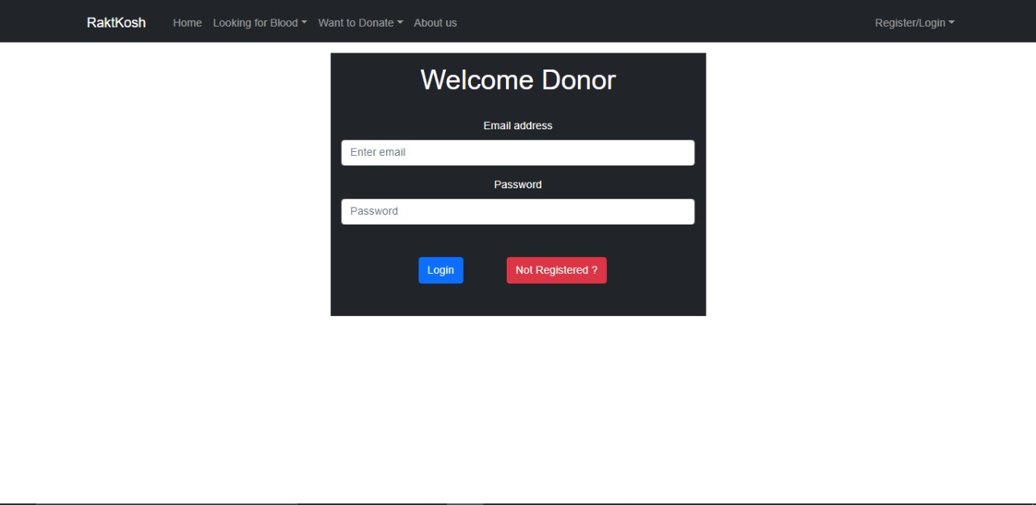

Donor Appointment Page

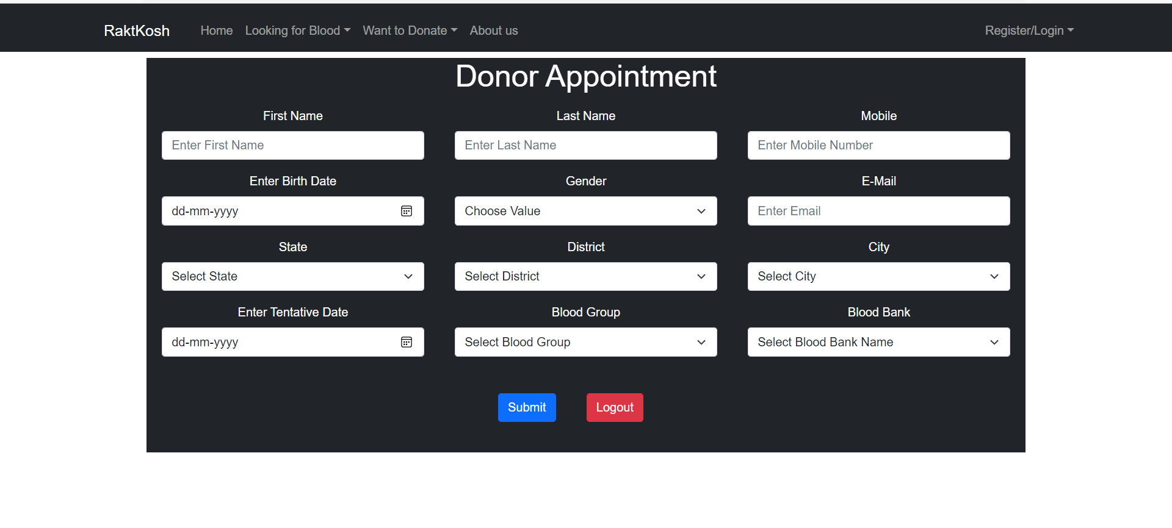

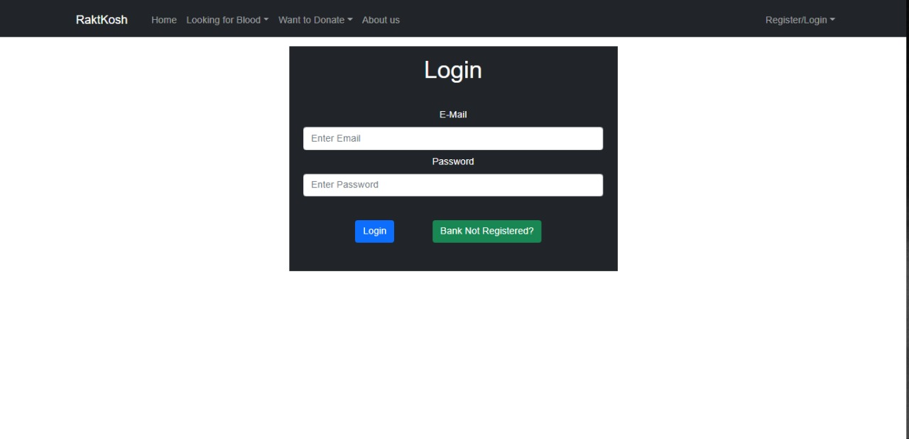Admin/BloodBank Login Page

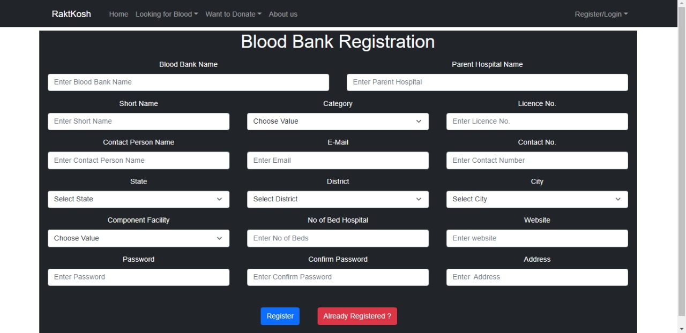Blood bank Registration Page

Frequently Asked Questions

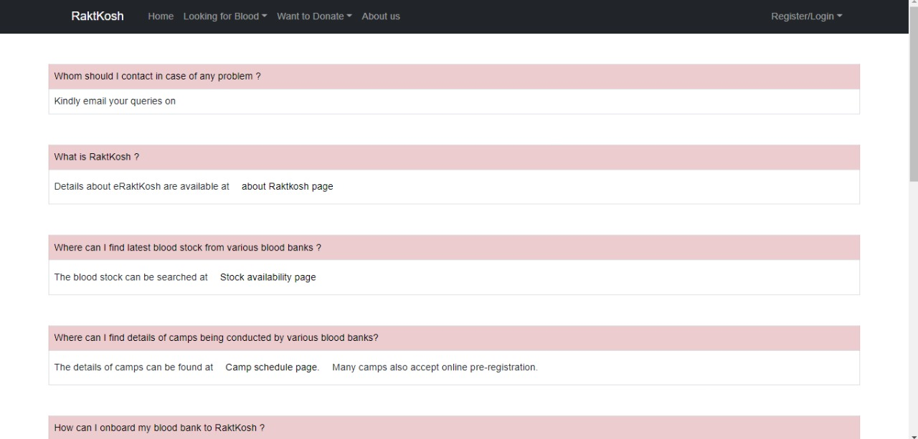

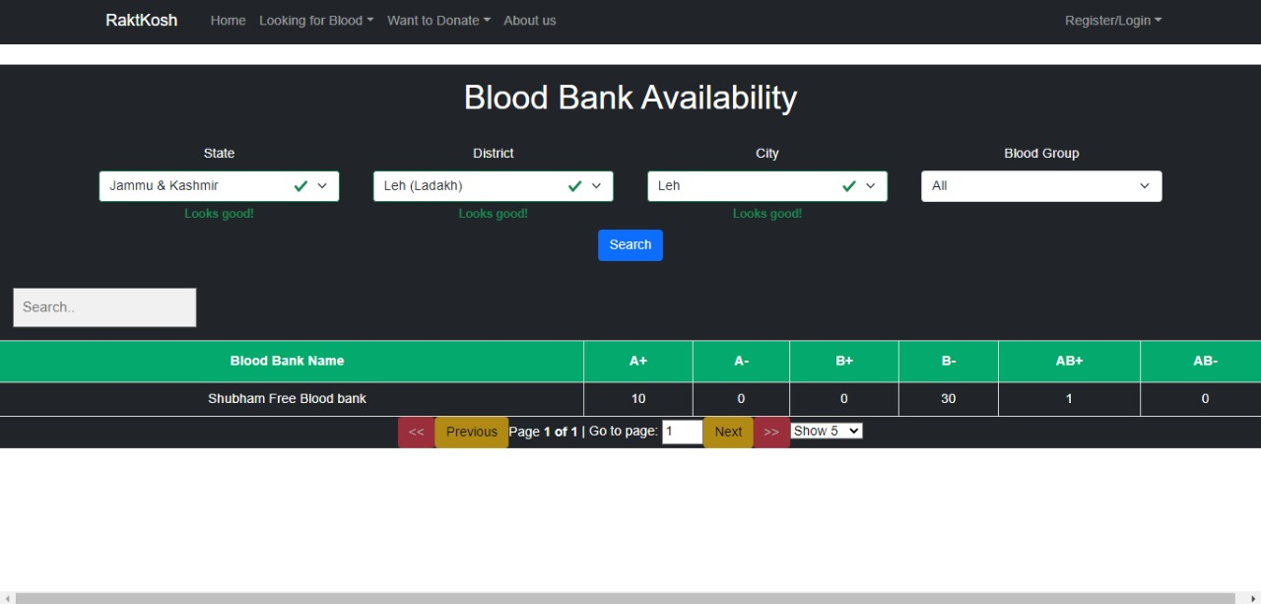Search for blood Availability

Search for Nearby Blood Bank

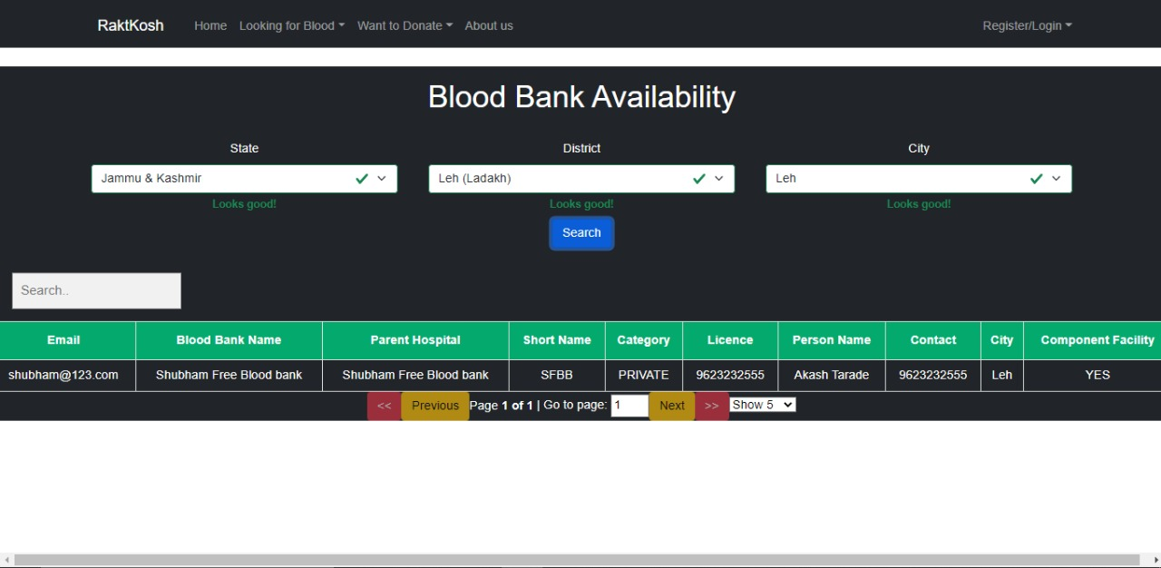

About Us Page

**~~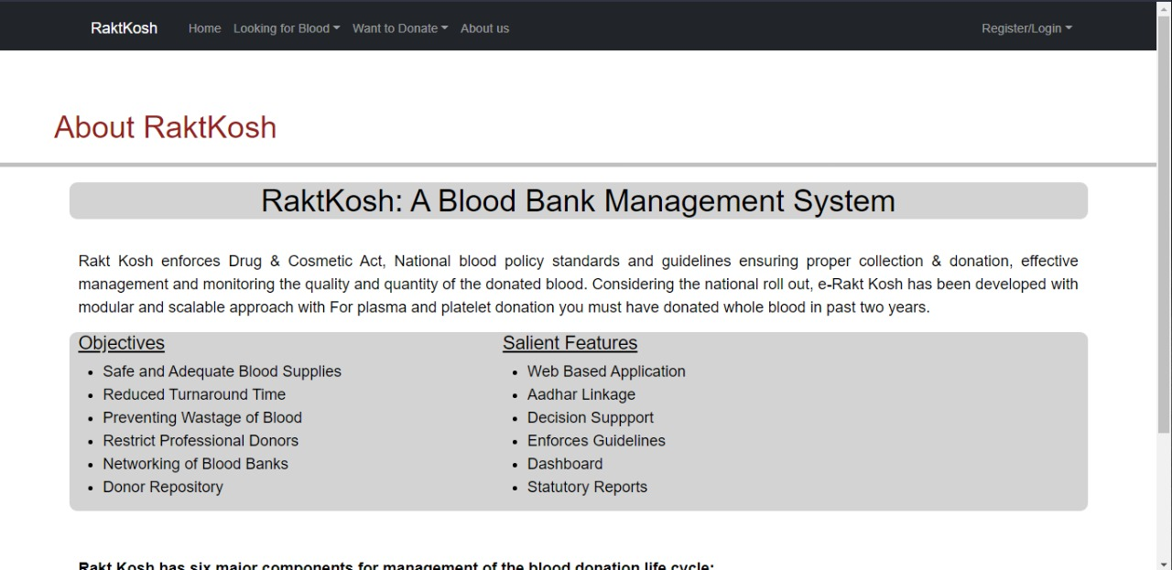~~**

Admin Home Page

**~~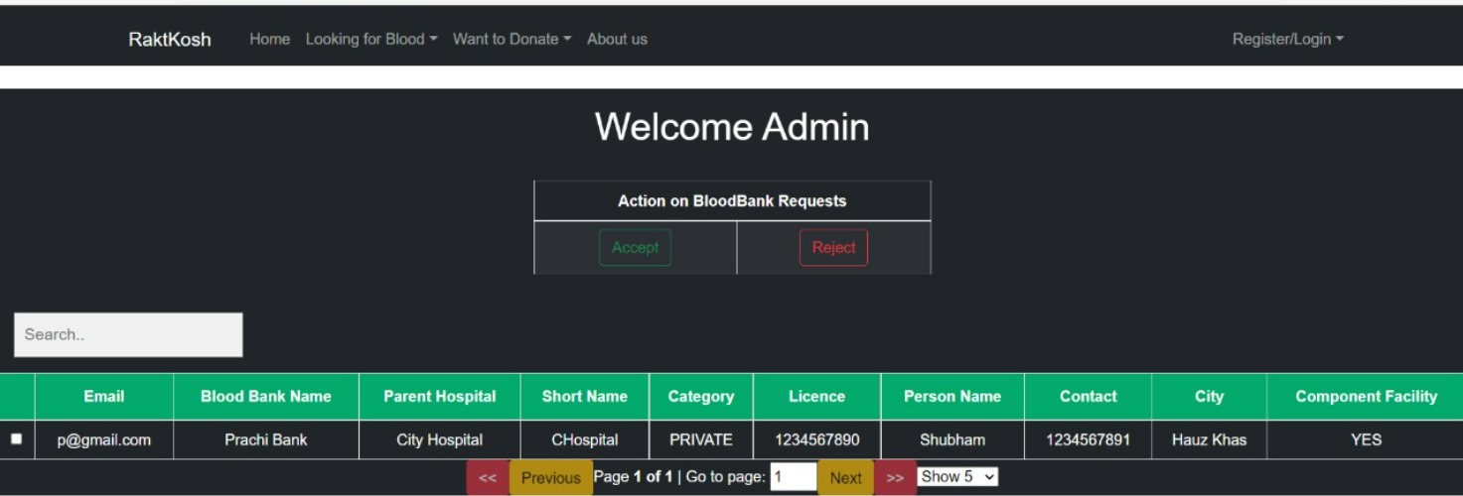~~**

Blood Bank Home Page

**~~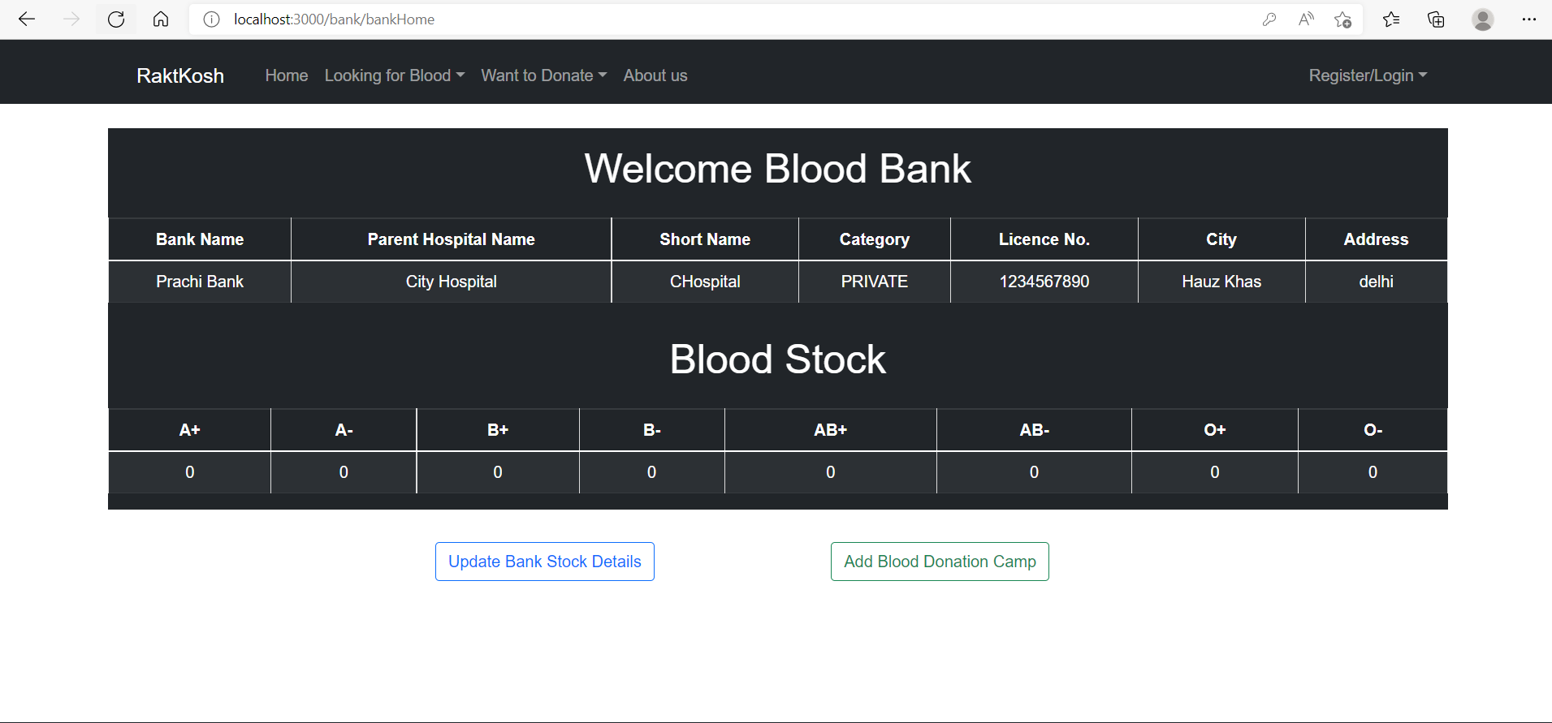~~**

1. **Advantages**

* Easy to access the customer data.
* Can review customer applications.
* Can know about which type of people are applying for home loan, which will became easy for marketing team to target the customers.

1. **Disadvantages**

* It requires active internet connection.

1. **Application**

* Bank can have details of each client who came for the enquiry for home loan.
* Easy to check CIBIL score.
* Can check application details and status.

1. **Future Scope: -**

* The main purpose to build this application program is to reduce the human efforts by using software.
* The project is totally built at administrative end and thus only the administrators guaranteed will access this system. This software is a mainly related to customer individuals who are interested in taking Home Loan from bank to fulfil their dreams.
* The process is filter by position to Official position.

1. **Conclusion :-**

* The web site provides synchronization between the employees of the bank.
* Here, the individual employee can find the data of all of all customers applying for loan, so that they can call them back for taking updates.
* It saves a lot of time for processing the request of the application.